MACH4METAL

metalworking machinery
Transito 21,
6909 DA BABBERICH
Netherlands
Tel. +31 (0)316 – 247123
Fax. +31 (0)316 - 247956
info@mach4metal.com
www.mach4metal.com

Bank No : 66.52.13.883
IBAN : NL33 INGB 0665 2138 83
BIC : INGBNL2A

Rapid Drill DONAU DANUMERIC 350
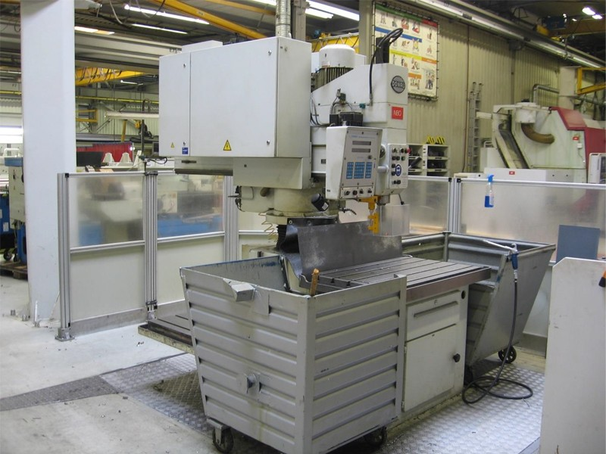

- Make : DONAU - Germany
- Type : DANUMERIC 350
- Age : 1995
- Serial : ………..

- Max. drilling Ø steel : 40
- Max. drilling Ø cast iron : 50
- Tapping M : 36

- Table length : 1.200
- Table width : 750
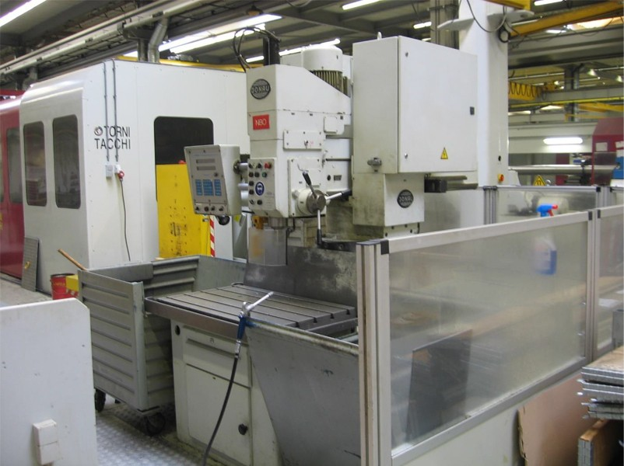

- Travel off radial arm : 800
- Working radious : 1.590
- Working height : 695
- Column Ø : 195

- Spindle taper : Sk 40
- Stroke spindle : 200
- Spindle speed : 2800 Rpm
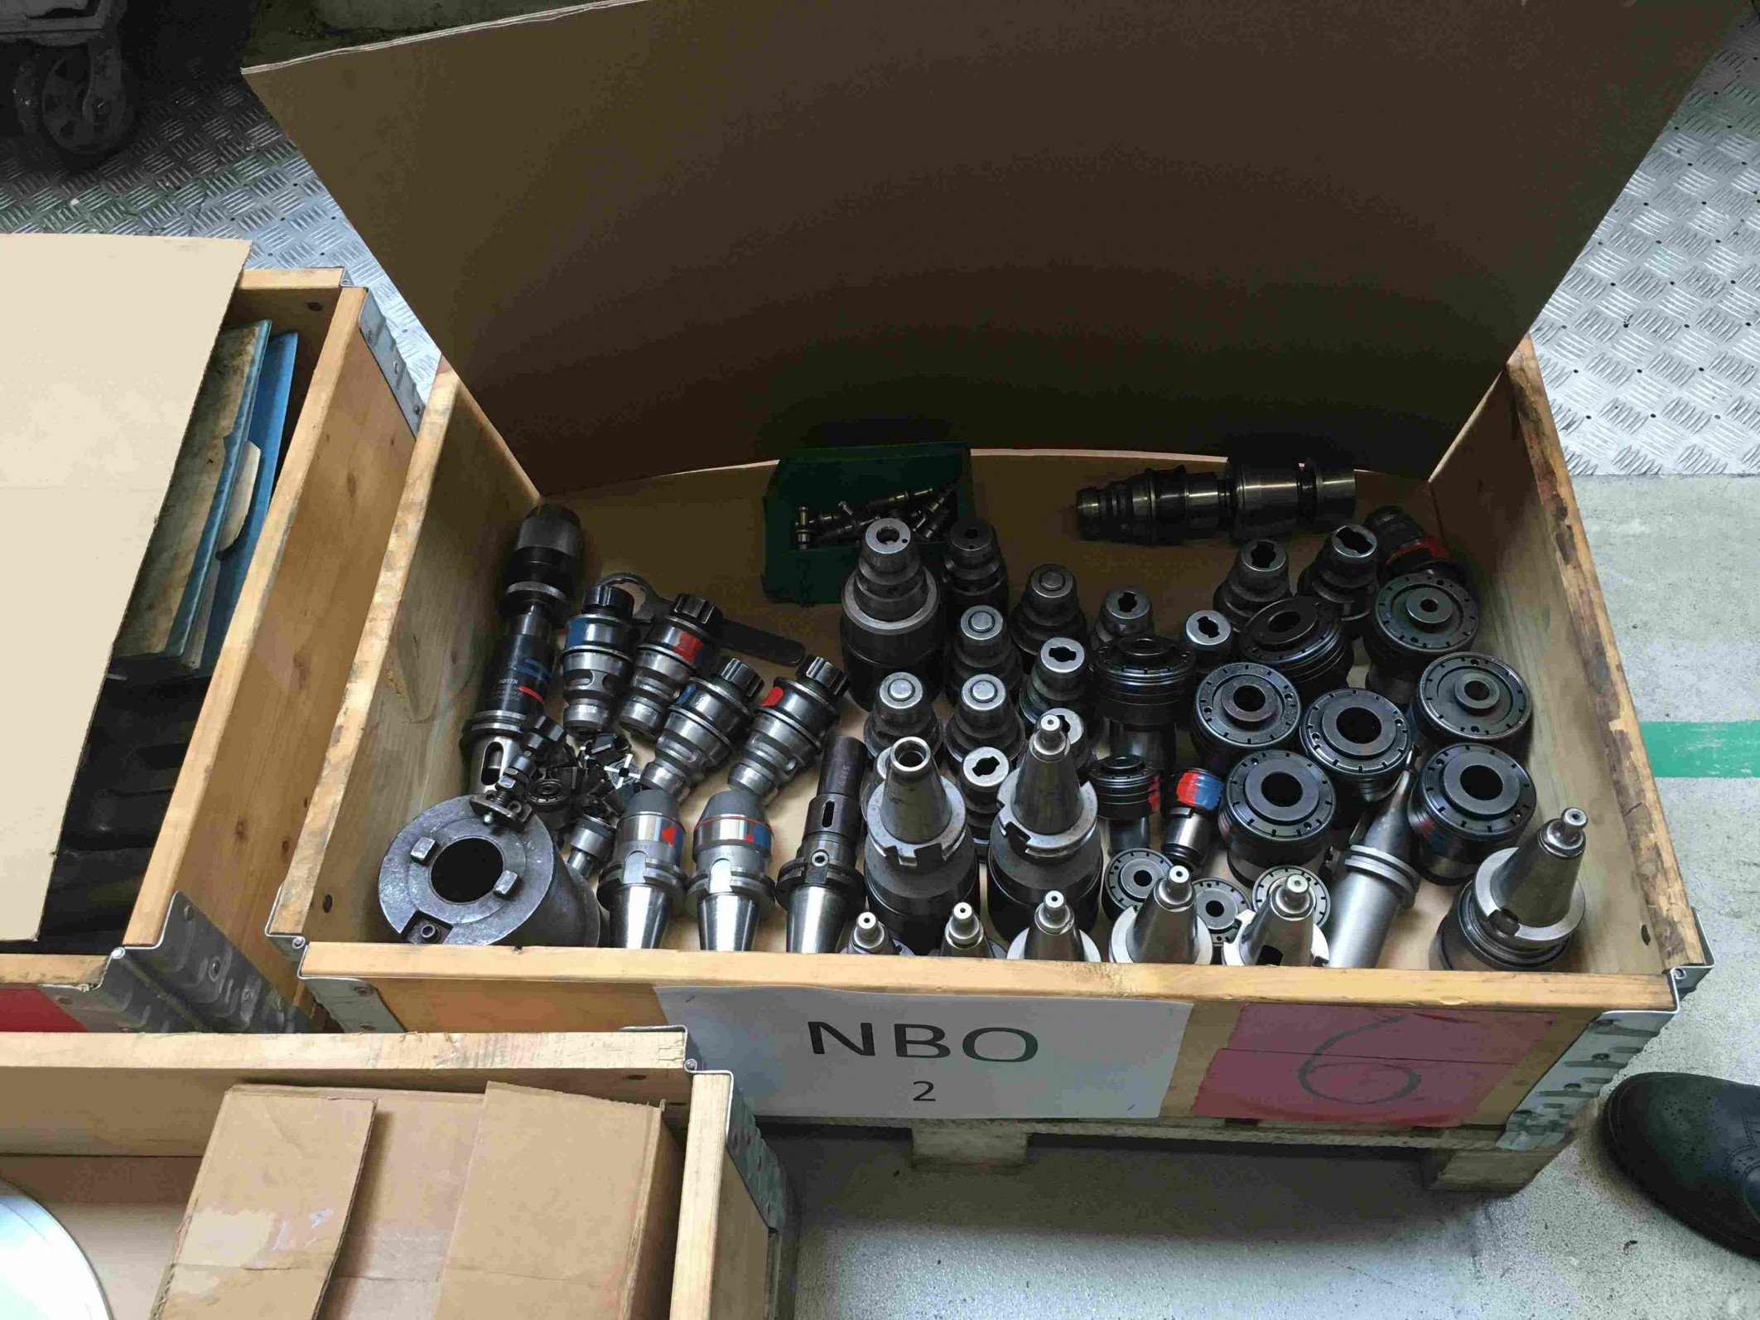
- Feed rate : 0,05 – 0,55
- Power : 5.5 kW
- Extra table : 800 x 600 mm
- Control system : DR 40 Digi
- Large tooling package

- Floor space : 3200 x 2600
- Total weight : 3500 Kg

Please Note: The above information has been obtained to the best of our ability and belief from, and from the manufacturers where possible. It is given in good faith, but its accuracy can not be guaranteed. Accordingly, it will not form a representation or constitute contractual terms. We advise you to check any vital details!

